The Impact of Modern Technology on The Financing of Startups In South Africa: Using Artificial Neural Networks.

BELMEBARKI Maroua¹ DJAFFERI Djamel ²
¹ Faculty of Economics, University of Algiers 3 (Algeria), belmebarkimaroua@gmail.com
² Faculty of Economics, University of Medea (Algeria), djafferi.djamel@univ-medea.dz

Received :25/04/2025 Accepted: 17/06/2026 Published :03/08/2026

Abstract:
This study investigates the predictive impact of modern technology on startup financing, with a particular focus on the relative roles of government support policies and entrepreneurial initiatives in South Africa over the period 2001–2024. To this end, an artificial neural network (ANN) model was employed, implemented via Python software, owing to its robust predictive capabilities in complex economic environments.
The empirical findings demonstrate the efficacy of both predictive models; however, forecasts derived from the government support variable consistently outperformed those based on the entrepreneurial initiatives variable. This outcome suggests that state-led policies are poised to exert a more pronounced influence on startup financing compared to entrepreneurial efforts, at least within the studied context. Nevertheless, the results do not undermine the potential for synergistic cooperation between the public and private sectors, which remains a critical avenue for advancing sustainable development objectives.
Keywords : Modern technology, startups, artificial neural network model (ANN).
I- Introduction
The contemporary global landscape has undergone profound and far-reaching transformations, largely driven by the rapid proliferation of modern technologies. These technologies have increasingly assumed a central role in fostering economic growth, as they catalyse innovation and enhance productivity across a wide array of sectors. In the context of escalating international trade in technology-intensive goods—encompassing both high-technology exports and imports, alongside information and communication technology (ICT) products—governments and entrepreneurs alike find themselves engaged in a continuous endeavour to devise and implement strategies and mechanisms capable of responding effectively to these paradigm shifts.
Within this dynamic environment, startups have emerged as pivotal actors in modern economies, contributing significantly to job creation, industrial renewal, and the stimulation of competitive dynamics. Nevertheless, these fledgling enterprises frequently encounter formidable obstacles in securing adequate and timely financing, a constraint that substantially impedes their developmental trajectories and scalability. It is at this juncture that the role of governmental intervention becomes salient, as states are increasingly called upon to institute supportive policy frameworks—whether direct or indirect—that facilitate access to capital and reduce informational asymmetries in financial markets. Concomitantly, the persistent efforts of entrepreneurs to navigate financing constraints significantly enhance the prospects of market expansion and institutional sustainability.
The foregoing considerations give rise to a critical inquiry concerning the interplay between technological advancement and the financing of startups, particularly as mediated by government support policies on the one hand, and entrepreneurial agency on the other. Moreover, exploring the intersection between public support mechanisms and private entrepreneurial initiatives offers a more nuanced understanding of the manner in which technology can serve to reinforce the broader entrepreneurial ecosystem. Accordingly, the central question guiding this investigation is articulated as follows:
How does modern technology influence the financing of startups through government support policies and entrepreneurial funding mechanisms?
In order to operationalise this overarching inquiry, the study addresses the following subsidiary research questions:
- To what extent do projections for the government support variable surpass those for entrepreneurial initiatives in financing startups in South Africa over the forecast period 2025–2029?
- How effective is the artificial neural network (ANN) model in predicting the impact of modern technology on startup financing in South Africa?
Research Hypotheses
In order to furnish preliminary responses to the research questions posited above, the following hypotheses are advanced:
- H₁: The government support variable exhibits higher projected values than the entrepreneurial initiatives variable, indicating a comparatively greater efficacy of state-led policies in sustaining startup financing.
- H₂: The artificial neural network model demonstrates significant predictive capacity in estimating the influence of modern technology on the financing of startups.
Objectives of the Study
The principal objectives of this study are delineated as follows:
- To develop a comprehensive conceptual framework that elucidates the nexus between modern technology and emerging entrepreneurial institutions.
- To comparatively assess the predictive roles of government support and entrepreneurial initiatives in forecasting the financing requirements of startups.
- To evaluate the accuracy and robustness of the employed models in simulating financial realities, while analysing the variance between projected outcomes for the two variables of interest.
- To estimate the impact of modern technology on financing mechanisms for emerging institutions in South Africa during the period 2025–2029.
Significance of the Study
This study derives its significance from several interrelated dimensions. First, it underscores the instrumental role of modern technology in shaping and refining support policies for emerging institutions, through the provision of predictive tools that enable decision-makers to anticipate future financing trajectories. Such foresight is indispensable for governmental bodies and funding institutions to recalibrate their strategic orientations in a proactive manner. Second, by shedding light on the financing dynamics of startups, the study contributes to the broader discourse on how these entities may be effectively leveraged to stimulate sustainable economic growth and structural transformation.
Research Methodology
To attain the stated objectives, the study adopts a mixed-method approach. Specifically, the descriptive approach is employed to address the theoretical dimension, encompassing a comprehensive review of the literature pertaining to modern technology and startups. Concurrently, the analytical approach is utilised to interpret the empirical findings derived from the applied segment of the research. In this regard, Python software is deployed for data processing and model implementation, thereby ensuring methodological rigour and enhancing the precision of the results obtained.
1. Theoretical Framework
This section delineates the foundational conceptual constructs underpinning the study, providing a systematic exposition of the principal variables and their interrelationships.
1.1. Modern Technology
Modern technology may be defined as an instrumental repertoire of methods, processes, and techniques applied within a given domain to achieve specific objectives. However, its conceptualisation extends beyond mere mechanical or digital artefacts; rather, it encompasses a harmonious synthesis of organised human activity, machinery, and environmental considerations, functioning as an integrated socio-technical system (Ahmadi, 2018).
The contemporary technological landscape is characterised by several transformative domains, the most salient of which are elucidated below:
Artificial Intelligence (AI): Artificial intelligence constitutes a branch of computer science concerned with the emulation of intelligent behaviour, encompassing perception, reasoning, learning, communication, and adaptation within complex and dynamic environments. The overarching objective of AI resides in the development of machines capable of executing tasks with a degree of efficiency commensurate with, or exceeding, that of human agents (Nilsson, 2008).
Internet of Things (IoT): The Internet of Things refers to a networked infrastructure that facilitates novel applications and services by establishing connectivity between the physical world and the internet through embedded sensors and actuators, typically operating autonomously without direct human intervention (Rose & Eldridge, 2015).
Cloud Computing: Cloud computing denotes the on-demand availability of computational resources—encompassing data storage and processing capacity—without necessitating active user management. Functionalities are distributed across geographically dispersed data centres, thereby enabling scalable and resilient service delivery (Islam et al., 2023).
Virtual Reality (VR) and Augmented Reality (AR): Virtual reality refers to immersive technologies that generate interactive environments characterised by visual realism. Conversely, augmented reality emerged with the proliferation of smartphones, enhancing the user's perception of the physical world by overlaying digitally generated elements—such as texts and three-dimensional graphics—onto real-world environments via mobile devices (Boyles, 2017).
Blockchain Technology: Blockchain constitutes a decentralised digital ledger system designed for secure transaction recording, underpinned by intelligent algorithms predicated on aggregated and cryptographically secured data. Its applications extend across financial markets, healthcare, and defence sectors, where it facilitates the design of novel technological models. Moreover, blockchain contributes to resolving challenges pertaining to trust and encryption through the utilisation of public-key infrastructure (Taghreed, 2019).
1.2. Startups
A startup is conceptualised as a temporary organisational entity established for the purpose of developing and validating a scalable and replicable business model, predicated on the introduction of innovative ideas to the market, with the ultimate aim of transitioning into an economically sustainable enterprise (Spender et al., 2017).
Notwithstanding their transformative potential, startups encounter a constellation of formidable challenges that threaten their viability. Drawing upon the synthesis provided (Banudevi & Shiva, 2019) these impediments may be categorised as follows:
- Absence of a Robust Entrepreneurial Ecosystem: The deficiency of a well-established entrepreneurial infrastructure constitutes one of the most pervasive obstacles confronting startups across national contexts. Although business incubators and accelerators have gradually emerged in numerous metropolitan centres, their coverage and efficacy remain insufficient to bridge the prevailing gap. Consequently, a significant proportion of startup ideas fail to materialise beyond the conceptual phase.
- Paucity of Support Networks and Financing Mechanisms: The entrepreneurial milieu is predicated upon platforms that facilitate interaction between investors and entrepreneurs. However, the limited availability of such intermediation mechanisms impedes the efficient allocation of capital, rendering it arduous for entrepreneurs to secure adequate funding and for investors to identify viable ventures. Furthermore, the number of active investors remains comparatively constrained relative to Western economies, a phenomenon attributable to elevated risk perceptions and the absence of coherent policy frameworks.
- Scarcity of Human Capital: Emerging ventures are frequently confronted with difficulties in attracting and retaining appropriately skilled talent, primarily owing to their financial precarity relative to established corporations or enterprises situated in more developed economies. This constraint undermines their capacity for innovation and operational effectiveness.
1.3. The Impact of Modern Technologies on Startups
Modern technologies have become increasingly pivotal in shaping the entrepreneurial landscape, fundamentally altering the operational modalities of startups and providing unprecedented opportunities for growth and differentiation. Drawing on the proposed analytical framework (Lawrence, 2024), the principal positive ramifications of technological integration may be delineated as follows:
• Enhancement of Operational Efficiency, Productivity, and Customer Experience: Technological advancements have had a dual impact on startups: on the one hand, they have revolutionized product development and refinement processes; on the other, they have transformed customer engagement paradigms. The deployment of digital marketing tools and customer relationship management (CRM) systems enables startups to attain and sustain competitive advantage within their respective markets.
• Expansion of Market Reach: The proliferation of digital technologies has effectively dissolved geographical barriers, empowering startups to extend their market presence beyond national and regional borders. This expanded accessibility is a critical determinant of long-term viability, as it facilitates the acquisition of a global customer base.
• Transformation of Organizational Structure and Culture: The advent of digital collaboration tools and remote work capabilities has engendered a fundamental reconfiguration of organizational architectures, enabling startups to operate with heightened flexibility and adaptability. In parallel, these enterprises have cultivated organizational cultures that emphasize experimentation, iterative learning, and problem-solving acumen, thereby reinforcing their capacity for innovation and resilience.
2. Experimental Framework.
At this stage, we initiate the analysis of the results with the aim of interpreting the outputs and testing the previously proposed hypotheses.
2.1. Model Design and Variable Specification
The present study endeavours to model the relationship between modern technology and startup financing, as mediated by two distinct channels: (i) government support policies, and (ii) entrepreneurial financing mechanisms, within the context of South Africa over the period 2001–2024. To operationalise this investigation, two separate artificial neural network (ANN) models are constructed, each corresponding to one of the aforementioned financing channels. The mathematical formulations of these models are expressed in equations (01) and (02) as follows:
Financing for entrepreneurs = F(HTE, IGE, IGI) … … … … (01)
Governmental support and policies = F(HTE, IGE, IGI)… … … … … (02)
Where:
- FE denotes Financing for Entrepreneurs
- GSP denotes Governmental Support and Policies
- HTE denotes High-Technology Exports
- IGE denotes ICT Goods Exports
- IGI denotes ICT Goods Imports
2.1.1. Data Sources
The empirical analysis draws upon annual time-series data spanning the period from 2001 to 2024, sourced from two principal international databases: the World Development Indicators (WDI) , provided by the World Bank, and the Global Entrepreneurship Monitor (GEM) . These repositories are widely recognised for their reliability and comprehensiveness in capturing macroeconomic and entrepreneurial dynamics across national contexts.
2.1.2. Variable Selection and Operationalisation
In accordance with the study's overarching objectives, the variables were meticulously selected to capture both the technological and financial dimensions germane to startup ecosystems in South Africa. The selection process was guided by theoretical relevance, data availability, and empirical precedents in the extant literature.
Dependent Variables (Labels):
The financing of startups constitutes one of the most pervasive challenges confronting entrepreneurial ventures, affecting both their inception and long-term sustainability. In recognition of the multifaceted nature of this challenge, the study operationalises two distinct dependent variables, thereby facilitating a comparative assessment of two support modalities:
- FE (Financing for Entrepreneurs): This variable captures the extent to which entrepreneurial initiatives secure financial resources from private or semi-private sources, reflecting the agency of entrepreneurs in mobilising capital.
- GSP (Governmental Support and Policies): This variable encapsulates the role of state-led interventions, including fiscal incentives, grants, and regulatory frameworks designed to facilitate access to finance for startups.
Consequently, two parallel ANN architectures are developed, each tailored to one dependent variable while maintaining consistent predictor specifications.
Independent Variables (Predictors):
To capture the technological dimension of the study, the following indicators were adopted as predictors, given their recognised capacity to reflect both the absorption and generation of technological capabilities:
- HTE (High-Technology Exports): This indicator measures the value of exports pertaining to high-technology products, serving as a proxy for technological sophistication and international competitiveness.
- IGE (ICT Goods Exports): This variable quantifies exports of information and communication technology goods, reflecting the domestic capacity for technology production and integration into global value chains.
- IGI (ICT Goods Imports): This variable captures imports of ICT goods, indicating the extent of technology diffusion and the reliance on foreign technological inputs.
The selection of these variables is predicated upon their theoretical relevance to the study's problematic and their empirical robustness in prior scholarly investigations.
2.2. Descriptive Statistics and Preliminary Data Analysis
Prior to the implementation of the artificial neural network models, a comprehensive descriptive analysis of the data was undertaken to ascertain the underlying statistical properties of the variables under investigation. This preliminary step is essential for ensuring data quality, identifying potential anomalies, and informing the subsequent modelling procedures. The descriptive statistics are presented in Table (01)
Tab (01) Descriptive statistics.
IGI | IGE | HTE | FE | GSP
23.0 8.772609 1.323488 6.760000 7.895000 8.190000 9.660000  11.350000 | 23.0 1.203478 0.284327 0.680000 0.990000 1.220000 1.420000  1.700000 | 23.0 5.756290 0.538215 4.895523 5.470348 5.654569 6.080765  6.687136 | 23.0 3.965841 0.245191 3.480000 3.825000 3.970000 4.094783  4.470000 | 23.0 4.580435 0.665019 3.300000 4.180000 4.630000 5.050000  5.800000 | count  mean std min 25% 50% 75%  max

Source: python output
The descriptive statistics reveal a substantial disparity between the two dependent variables, with Financing for Entrepreneurs (FE) exhibiting a considerably higher mean (8.772609) compared to Governmental Support and Policies (GSP) (1.323488), indicating that entrepreneurial financing mechanisms have historically dominated the funding landscape in South Africa. Among the independent variables, High-Technology Exports (HTE) records the highest mean (5.756290), suggesting a relatively stronger technological export capacity, while ICT Goods Imports (IGI) demonstrates the greatest variability (Std. Dev. = 0.665019), reflecting episodic surges in technological imports. The relatively low standard deviations for IGE (0.245191) and GSP (0.284327) indicate notable stability in ICT exports and government support policies over the study period. The positive skew observed in FE and IGI suggests that most observations cluster at lower values, with occasional years recording substantially higher figures, which warrants consideration in the subsequent ANN modelling phase. Overall, these findings underscore the asymmetric nature of startup financing channels in South Africa and highlight the need for a comparative analytical approach.

2.2.4. Correlation Heatmap and Multicollinearity Assessment
To examine the bivariate relationships among the study variables and detect potential multicollinearity issues that might compromise the stability of the ANN models, a Pearson correlation matrix was computed. The results are presented in Figure (01) below.
Figure (01) Correlation Heatmap
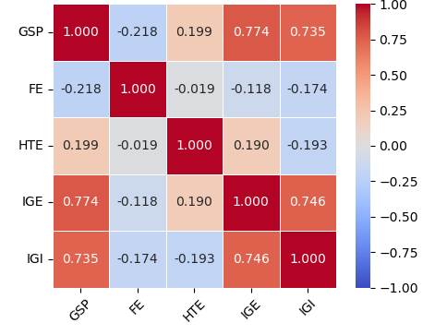

Source: python output
The correlation Heatmap reveals strong positive relationships between Governmental Support and Policies (GSP) and both ICT Goods Exports (IGE = 0.774) and ICT Goods Imports (IGI = 0.735), suggesting that technological trade flows are closely associated with government support mechanisms in South Africa. Conversely, Financing for Entrepreneurs (FE) exhibits weak negative correlations with all independent variables, indicating that entrepreneurial financing operates independently of technological trade indicators. High-Technology Exports (HTE) demonstrates negligible correlations with FE (-0.019) and IGI (-0.193), implying a limited direct association with these variables. Notably, the strong correlation between IGE and IGI (0.746) raises potential multicollinearity concerns, warranting careful consideration in the ANN model specification to avoid estimation biases. Overall, these findings suggest that government support and entrepreneurial financing represent two distinct and largely uncorrelated channels of startup funding.
3.2 Data Processing
In this phase, a series of data preprocessing operations were undertaken to enhance the quality and suitability of the dataset for artificial neural network modelling. These operations encompassed outlier detection and treatment, as well as data normalisation.
2.3.1. Outlier Detection and Treatment
Outliers can exert a disproportionate influence on statistical models, potentially distorting parameter estimates and undermining predictive accuracy. To identify the presence of anomalous observations within the dataset, a Box Plot test was employed. The results of this diagnostic procedure are presented in Table (03).
Table (02): Results of the Box Plot Outlier Detection Test
IGI | IGE | HTE | FE | GSP | The variables
No outliers detected in the dataset | No outliers detected in the dataset | The presence of an outlier value | The presence of an outlier value | No outliers detected in the dataset | The presence of outliers

Source: python output
As evidenced by Table (02), outlier values were detected in two variables: Financing for Entrepreneurs (FE) and High-Technology Exports (HTE) . To mitigate the adverse effects of these extreme observations while preserving the integrity of the dataset, the identified outliers were replaced with the mean values of their respective variables. The post-treatment dataset is presented in Appendix (1-2).
2.3.2. Data Normalisation
Following outlier treatment, a normalisation procedure was applied to the entire dataset. This process entails the rescaling of numerical values to a bounded interval, typically [0, 1], through min-max scaling. This transformation is particularly pertinent in the context of artificial neural networks, as such models exhibit enhanced convergence properties and computational efficiency when processing standardised input values within a limited range.
2.4 Data Segmentation
In accordance with standard practices in machine learning, the preprocessed dataset was partitioned into two distinct subsets: a training set and a testing set. The segmentation was performed randomly using Python software, with the allocation ratios reflecting the need for sufficient training data while retaining an adequate holdout sample for model evaluation. Table (04) delineates the data partitioning scheme.
Table (03): Data Partitioning Results
The ratio | The number | The groups
80%  20%  100% | 19  5  24 | Training set  Testing set  Total views

Source: python output
As indicated in Table (03), 80% of the observations (19 entries) were allocated to the training set, while the remaining 20% (5 entries) were reserved for testing purposes. This configuration ensures that the models are trained on a sufficiently representative sample while enabling rigorous out-of-sample evaluation.
2.5 Construction of Artificial Neural Network Models
As previously elucidated, this study entails the development of two distinct artificial neural network architectures, each corresponding to one of the dependent variables under investigation. Both models were constructed using the Sequential API, which facilitates the incremental addition of layers in a linear stack. The architectural specifications of the two models are summarised in Table (04).
Table (04) : Architectural Specifications of the ANN Models
Model One: Label is Financing for entrepreneurs |  |  |  | The second model: Label is Governmental support and policies
Input layer | The Hidden Layer |  | Output layer | Input layer | The Hidden Layer |  | Output layer
The predictors consist of three variables: HTE, EGI, and IGI. | Dense Layer | RELU activation function | Single Neuron | The predictors consist of three variables: HTE, EGI, and IGI. | Dense Layer | RELU activation function | Single Neuron

Source: python output
As depicted in Table (04), both models share an identical architectural blueprint, comprising an input layer with three predictor variables (HTE, IGE, IGI), a single hidden layer employing the Rectified Linear Unit (ReLU) activation function, and an output layer consisting of a single neuron. The ReLU activation function was selected owing to its demonstrated efficacy in accelerating learning convergence and mitigating the vanishing gradient problem commonly encountered in deep neural networks.
2.6 Model Compilation
Following the architectural definition of the models, the compilation phase was undertaken to configure the learning process. This stage involves the specification of the loss function, optimisation algorithm, learning rate, and performance metrics. Additionally, a systematic variation of the number of neurons in the hidden layer was implemented across multiple iterations to identify the optimal configuration. Table (05) presents the compilation parameters for both models.
Table (05): Model Compilation Parameters
Model One: Label is Financing for entrepreneurs |  |  |  |  |  | The second model: Label is Governmental support and policies
 | Loss function | Optimizati  -on Algorithm | Learning rate | Performance Metric | Number of Tested Models | Loss function | Optimizati-on Algorithm | Learning rate | Perform-ance Metric | Number of Tested Models
 | Mean Squared Error | Adam Optimizer | 0.0001 | Mean Absolute Error | 12 | Mean Squared Error | Adam Optimizer | 0.001 | Mean Absolute Error | 10

Source: python output
As illustrated in Table (05), the Mean Squared Error (MSE) was employed as the loss function for both models, while the Adam optimiser was selected for its adaptive learning rate capabilities and computational efficiency. The Mean Absolute Error (MAE) was designated as the primary performance metric to facilitate interpretability. It is noteworthy that the learning rate was set at 0.0001 for Model One and 0.001 for Model Two, reflecting a calibration tailored to the distinct characteristics of each dependent variable. Furthermore, a total of 12 model variants were tested for FE and 10 for GSP, with the number of neurons in the hidden layer systematically varied across iterations to identify the optimal configuration prior to the training phase.
2.7 Phase Six: Model Training
In this phase, the models were trained by iteratively minimising the error between the actual and predicted values through systematic weight adjustment via backpropagation and gradient descent optimisation. The training parameters for both models are delineated in Table (06).
Table (06): Training Parameters of the Two Models
Model One: Label is Financing for entrepreneurs |  | The second model: Label is Governmental support and policies
Epochs | Batch size | epochs | Batch size
30 | 6 | 40 | 4

Source: python output
As indicated in Table (06), Model One (FE) was trained over 30 epochs with a batch size of 6, while Model Two (GSP) was trained over 40 epochs with a batch size of 4. It is noteworthy that the training process was conducted exclusively on the training subset, with the testing set reserved for subsequent evaluation to ensure an unbiased assessment of predictive performance.
2.7 Optimal Model Selection
To ascertain the predictive capability of the models, a rigorous evaluation was conducted based on two performance criteria: Loss (Mean Squared Error) and Mean Absolute Error (MAE) . A total of 12 model variants were tested for FE and 10 variants for GSP, with the number of neurons in the hidden layer systematically varied across iterations. The results of this comparative evaluation are presented in Table (07).
Table (07): Optimal Model Selection Results
Tested Model Number | Model One: Label is Financing for entrepreneurs |  | The second model: Label is Governmental support and policies
Tested Model Number | Mean Absolute Error | Loss | Mean Absolute Error | Loss
01  02  03  04  05  06  07  08  09  10  11  12 | 0.2191  0.4855  0.3670  0.3365  0.2979  0.3272  0.3252  0.3850  0.2593  0.3766  0.3980  0.4123 | 0.0766  0.2895  0.1934  0.1357  0.1365  0.1630  0.1602  0.2210  0.0715  0.1959  0.2343  0.2566 | 0.7254  0.3726  0.3730  0.4075  0.4218  0.3559  0.3635  0.3662  0.4458  0.4413 | 0.7211  0.2094  0.1908  0.2105  0.2269  0.1842  0.2208  0.1867  0.2521  0.2509
The result | The optimal model is Model No. 09 |  | The optimal model is Model No. 06

Source: python output
As evidenced by Table (07), Tested Model No. 09 was selected as the optimal architecture for Model One (FE), exhibiting the lowest MAE (0.2593) and Loss (0.0715) values. For Model Two (GSP), Tested Model No. 06 was chosen, demonstrating the most favourable performance metrics with an MAE of 0.3559 and Loss of 0.1842. These selections were predicated on the principle of minimising both error metrics to ensure robust predictive accuracy.
2.9. Phase Eight: Training Results of the Optimal Models
Following the selection of the optimal architectures, the training process was visualised to illustrate the performance evolution with increasing epochs. Figure (01) depicts the convergence behaviour of both models.
Figure (02): Performance Evolution of the Two Models with Increasing Epochs

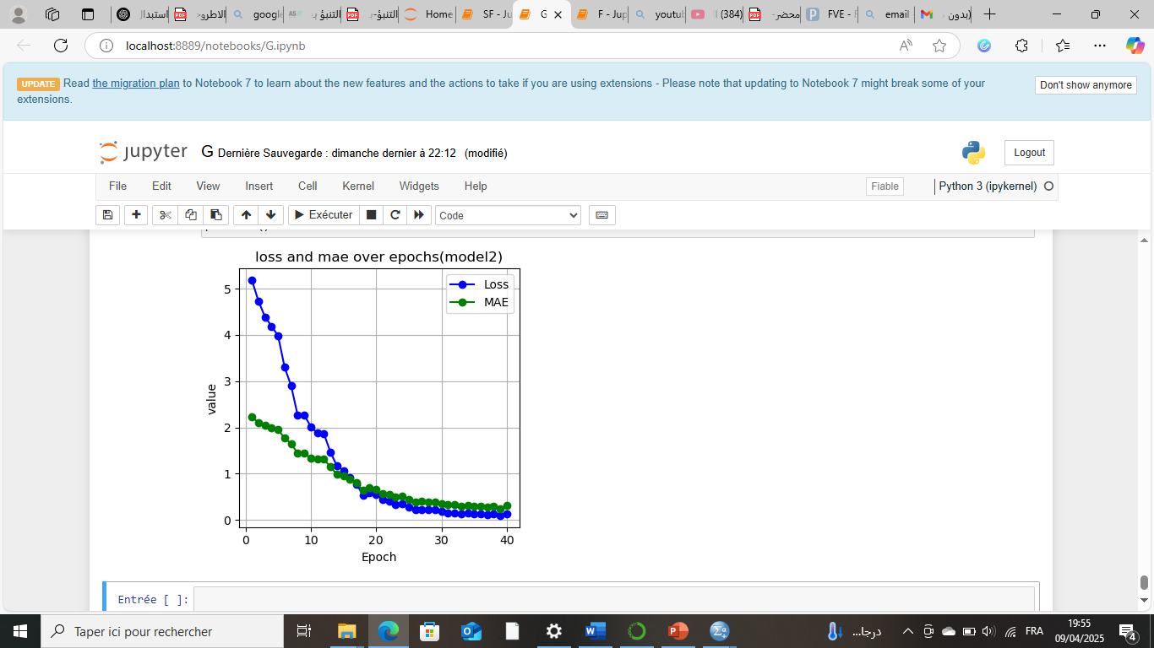
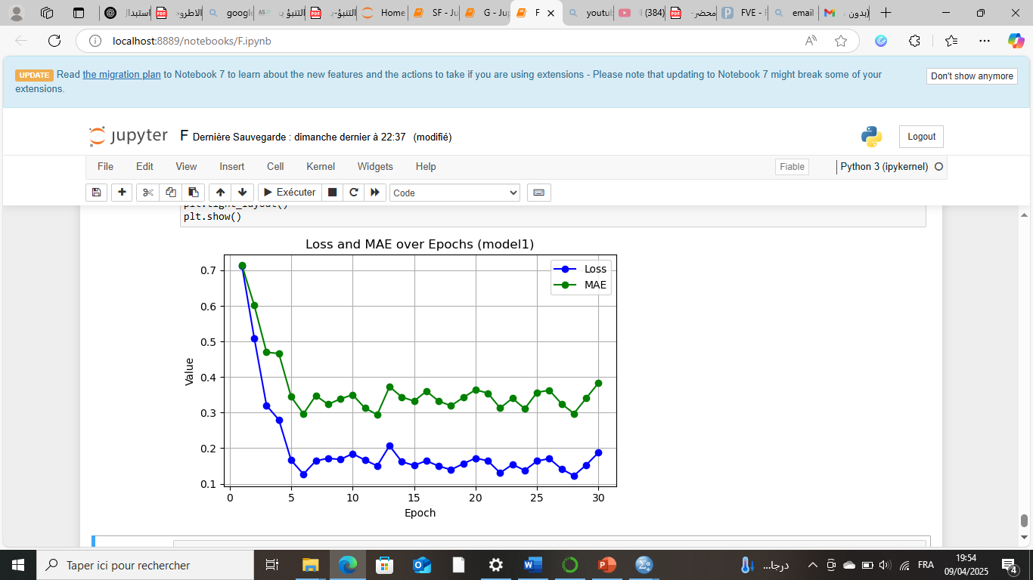

Source: python output

As shown in Figure (02), a discernible decline in both Loss and MAE is observed as the number of epochs increases, indicating that both models are progressively converging towards minimal error levels. Notably, the number of hidden layers and neurons was meticulously selected to circumvent the common pitfalls of overfitting (where the model captures noise rather than underlying patterns) and underfitting (where the model fails to capture the underlying structure of the data). This careful architectural design ensures that the models generalise effectively to unseen data.
2.10: Model Evaluation
To validate the actual performance and predictive capability of the two optimal models, an examination of the alignment between actual and predicted values was undertaken. Figure (02) provides a graphical representation of this comparative analysis.
Figure (03): Graphical Representation of Predicted vs. Original Values
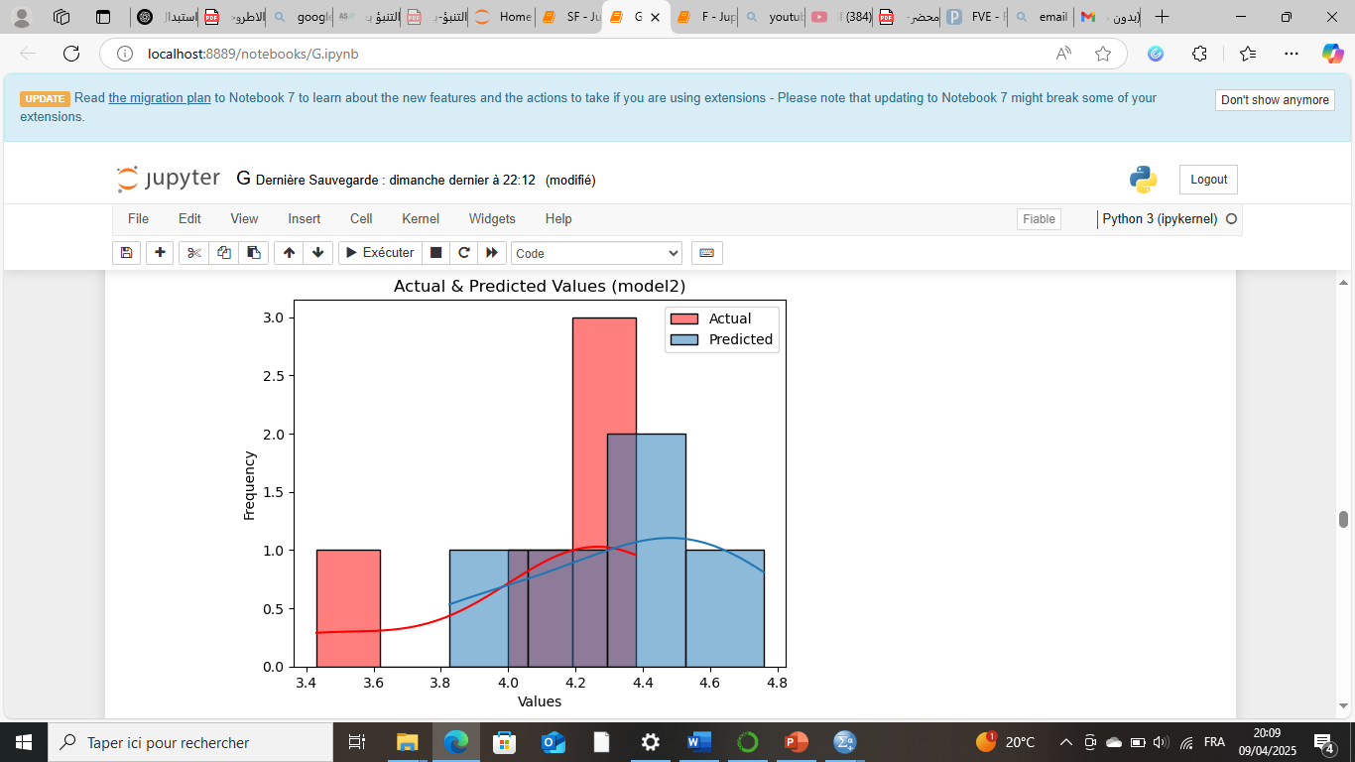
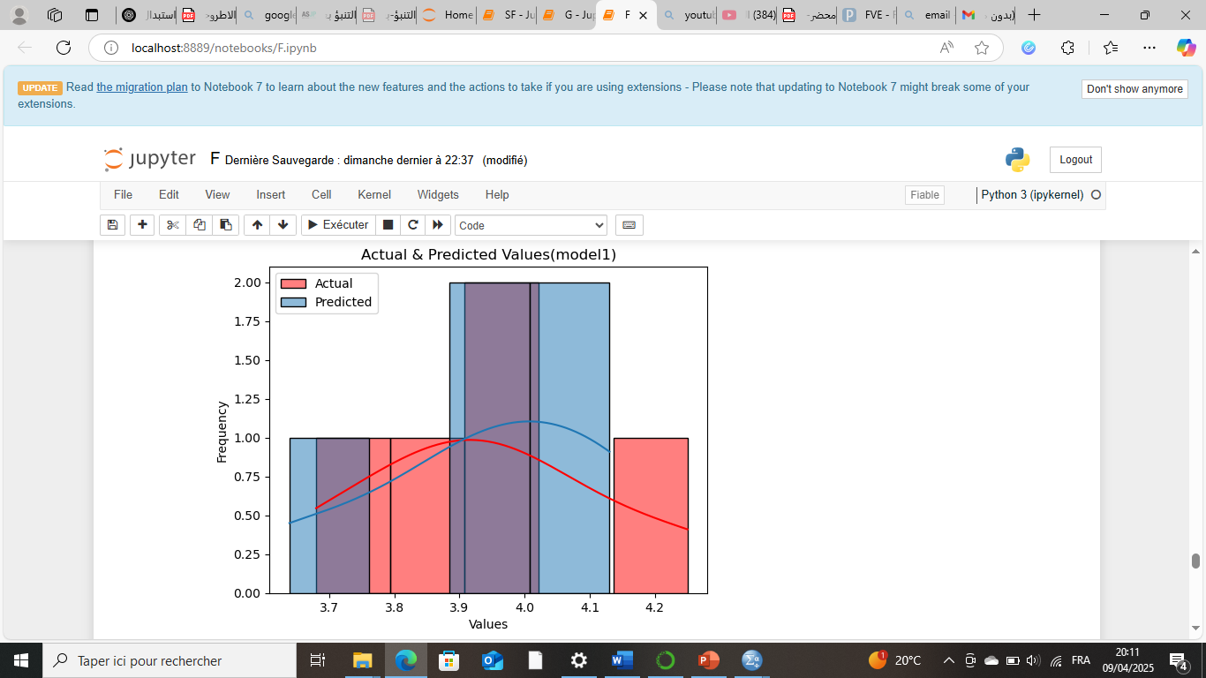

Source: python output

As illustrated in Figure (03), there is a notable proximity between the actual and predicted values across both models, as evidenced by the tight clustering of data points around the diagonal line of perfect prediction. This visual evidence corroborates the quantitative metrics presented earlier, affirming the accuracy and reliability of the two models employed in the forecasting process.

2.11 Prediction Stage
Upon confirming the efficiency and predictive validity of the two models, forecasts for the upcoming years (2024–2028) were generated. Table (09) presents the predicted values for both dependent variables over the forecast horizon.
Table (08): Predicted Values of the Two Models (2025–2029)
Model One: Label is Financing for entrepreneurs |  | The second model: Label is Governmental support and policies
The year | Prediction | The year | Prediction
2025 | 4.0929794 | 2025 | 4.464556
2026 | 4.130337 | 2026 | 4.5220475
2027 | 3.6390345 | 2027 | 3.8259177
2028 | 3.9021528 | 2028 | 4.7596145
2029 | 3.9341207 | 2029 | 4.172476
Source: python output
Based on the predictions delineated in Table (08), several salient observations emerge:
First, the Governmental Support and Policies (GSP) variable consistently records higher predicted values compared to the Financing for Entrepreneurs (FE) variable across all years of the forecast period (2024–2028). This disparity suggests that future government support policies are poised to play a more pronounced and effective role in bolstering startups relative to entrepreneurial initiatives. This finding carries significant policy implications, indicating that state-led interventions may be increasingly instrumental in shaping the startup financing landscape in South Africa.
Second, although GSP demonstrates superior predictive values, the forecasts for both variables exhibit temporal fluctuations. GSP predictions range from a minimum of 3.8259177 (in 2026) to a maximum of 4.7596145 (in 2027), while FE predictions fluctuate between 3.6390345 (in 2026) and 4.130337 (in 2025). These variations suggest a degree of volatility in both financing channels, potentially reflecting broader macroeconomic dynamics and policy adjustments.
Third, and most significantly, the results reveal a clear indication of synergy and complementarity between the government sector and entrepreneurial initiatives. While government support is projected to dominate, the sustained presence of entrepreneurial financing underscores the collaborative interplay between public and private actors in the pursuit of sustainable development objectives. This dual-channel approach appears essential for fostering a resilient and dynamic startup ecosystem in South Africa.
3. Conclusion
This study examined the impact of modern technology on startup financing in South Africa over the period 2001–2024, focusing on two channels: government support policies and entrepreneurial financing mechanisms. An Artificial Neural Network (ANN) model was employed to develop a predictive framework for estimating startup support levels.
3.1. Summary of Findings
The study yielded the following key findings:
- Outliers detected in Financing for Entrepreneurs (FE) and High-Technology Exports (HTE) were addressed by replacing them with their respective means.
- Min-max normalisation was applied to scale all values to [0, 1], enhancing the convergence properties of the ANN models.
- Based on Loss (MSE) and Mean Absolute Error (MAE) criteria, Experimental Model No. 09 was selected for the first model (FE), and Experimental Model No. 06 for the second model (GSP).
- A significant decrease in both Loss and MAE was observed during training, indicating successful convergence. The number of layers was carefully calibrated to avoid overfitting and underfitting.
- Notable closeness between actual and predicted values affirmed the accuracy and reliability of both models in the forecasting process.
- The government support variable (GSP) consistently recorded higher predictions than the entrepreneurs' variable (FE) across 2025–2029, suggesting that government policies are poised to play a more effective role in supporting startups, while both sectors continue to collaborate to achieve sustainable development.
3.2. Recommendations
Based on the findings, the following recommendations are proposed:
- Establish strategic partnerships between government, entrepreneurs, and investors to enhance access to financial resources.
- Encourage investment in startups through tax incentives, legal facilitation, and streamlined regulatory frameworks for investors.
- Adopt digital transformation in financing services through electronic platforms to simplify procedures and reduce bureaucracy.
- Promote a culture of creativity and innovation through educational initiatives and capacity-building programs to enable startups to effectively benefit from support schemes.
3.3. Limitations and Future Research
This study is confined to the South African context, which may limit generalisability. Future research could incorporate additional variables, employ higher-frequency data, or apply alternative machine learning algorithms for comparative analysis.
.4References
Achibane, M., & Tlaty, J. (2018). The Entrepreneurial Finance and the Issue of Funding Startup Companies. European Scientific, 14(13), 268-279.
Ahmadi, M. (2018). The Use of Technology in English Language Learning: A Literature Review. International Journal of Research in English Education , 3(2), 115-125.
Boyles, B. (2017). Virtual Reality and Augmented Reality in Education. Center For Teaching Excellence, United States Military Academy, West Point, Ny, 67, 1-12.
Spender, J.-C., & Al. (2017). Startups and open innovation:a review of the literature. European Journal of Innovation Management, 20(1), 4-30.
Banudevi, P., & Shiva, G. (2019). Understanding the Financing Challenges Faced By Startups in India. Journal of Management and Science , 9(4), 284-287.
Islam, R., & AL. (2023). The Future of Cloud Computing: Benefits and Challenges. Scientific Research Publishing, 16(4), 53-65.
Lawrence , E. (2024). The Impact of Technology on Entrepreneurship: A Case Study of Digital Startups. Ladoke Akintola University of Technology, 1-16.
Nils, N. (2008). Artificial Intelligence A New Synthesis. San Francisco, California: Morgan Kaufmann.
Rose, K., & Eldridge, S. (2015). The internet of things: An overview‏. The internet society (ISOC), 80(15), 1-53.
Taghreed , J. (2019). Blockchain Technologies: Opportunities for Solving Real-World Problems in Healthcare and Biomedical Sciences. National Library Of Medicine, 27(4), 284-291.
.5Appendices.

Appendix (1): Results of the Box Plot Test
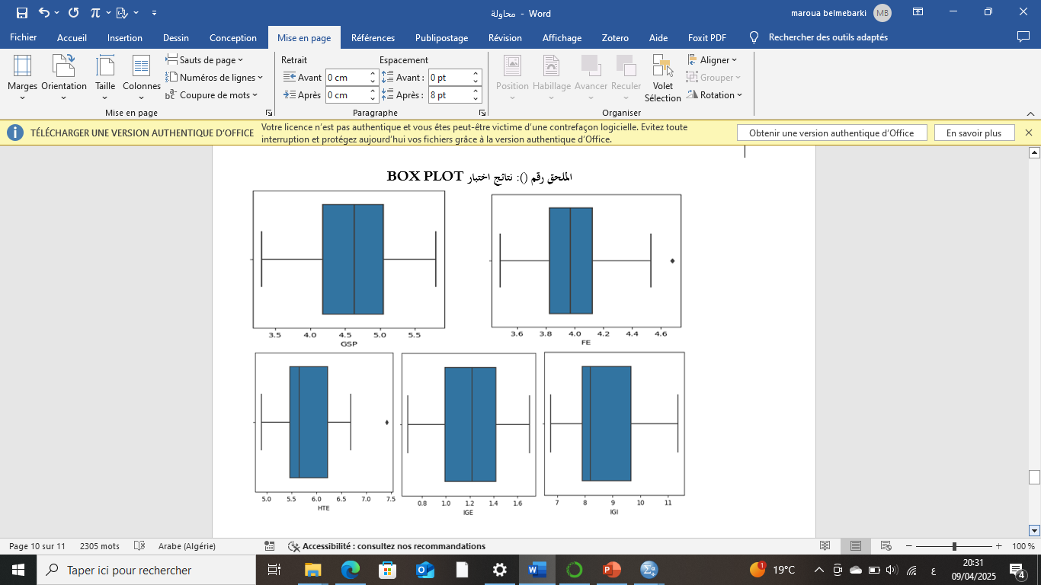


Appendix (2): Results of the Box Plot Test Following Outlier Removal

